Business Formation Proposal

Date: {{ date }}
License Activity | {{ business_name }}
License Authority | Dubai Mainland-Dubai Economy & Tourism (DET)



The Dubai Economy & Tourism (DET) is a government agency in Dubai, United Arab Emirates (UAE), responsible for regulating and supporting economic activity in the emirate. Its mandate includes issuing business licenses, regulating commercial activities, and promoting economic growth and development. Businesses that operate in Dubai Mainland are required to obtain a commercial license from the Dubai Economy & Tourism (DET) and comply with various regulations and procedures set by the DET and other government entities.

Approximate Costing of Company Incorporation

Business Formation-Dubai Mainland (DET)
Particulars | AED | USD
{{#items}}{{label}} | {{amount}} | $ {{amount_usd}}{{/items}}
Total | {{total}} | $ {{total_usd}}
***Please note: - process will start after confirmation of payment, POP must be sent to a designated member)
****Please note that the external approval, if any will be paid on actuals

Add-on services
Add-on Services
Particulars | AED | USD
VAT Registration | 750 | 205
Corporate Tax Registration | 500 | 136
VAT Filing (Based on number of transaction) | 850 | 232
Accounting Services (Less than 10 transactions per month) | 800 | 220
Accounting Services (10 to 20 transactions per month) | 1100 | 300
Accounting Services (20 to 30 transactions per month) | 1300 | 355
Accounting Services (30 to 50 transactions per month) | 1600 | 436
Accounting Services (More than 50 transactions per month) | Rate will be customized | Rate will be customized

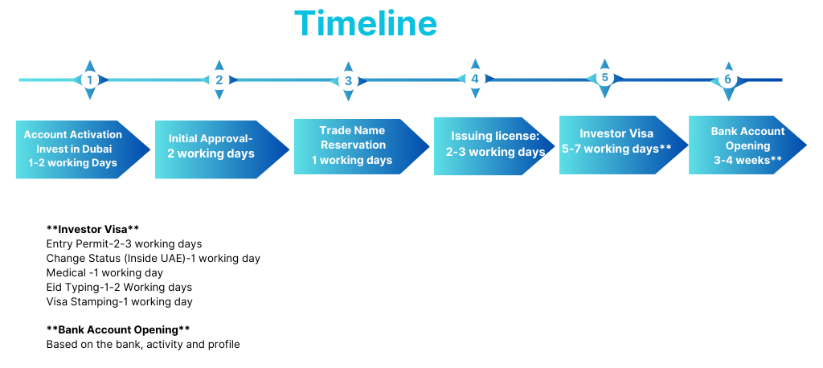

Terms & Conditions:

Documents Required
- Full Spread & Uncut Passport of the owner/partners & resident page (if any)
- High Resolution Passport size photo (white background only)
- Minimum 3 company names options
- Email ID of Investor/Partner
- Active Contact Number and address of Partners.

Payment Terms

- 100% down payment to start the process

Scope of work

- Preparation & Submission of Application
- Preparation/Review of Memorandum of Association
- Preparation/Review of Lease Agreement
- Assisting in Legal Attestation of documents
- Liaison with legal Department, lease & Licensing Department.
- Obtaining Trade License.
- Obtaining Attested Original Memorandum of Association (AOA, if any)
- Obtaining Certificate of Formation and other legal document

Notes:
- The license fee is calculated based on an approximate amount. The actual fee will be as per the payment voucher issued by the Authority in case of mainland License.
- All Government and Regulatory charges are borne by the Customer on an actual basis.
- Above are indicative charges current based on current promotions and might be variable.
- More than one business Activities should be from same field or extra charges will be applied as per authority.
- Branch company activity should match with the parent company.
- Depending on the nature of your business activity, you may need to submit additional documents to obtain approvals from other government bodies.
- IJARI charges will be separated in case of Office.
- *Plus, Applicable Taxes.

Contact: - Bharat Bajaj

+971-523655193

info@abcapital.ae www.abcapital.ae



